[Paper Title]

First author name¹, Second author name²
¹first author affiliation, ²second author affiliation
John Donne¹, William Shakespeare², Joseph Conrad¹
¹ABC Corp., ²XYZ Ltd.

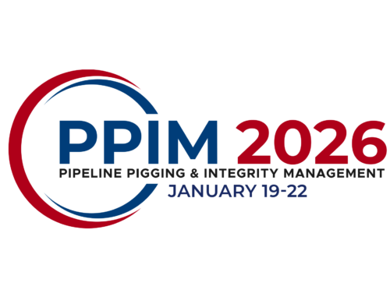

Organized by


Proceedings of the 2026 Pipeline Pigging and Integrity Management Conference.
Copyright © 2026 by Clarion Technical Conferences and the author(s).
All rights reserved. This document may not be reproduced in any form without permission from the copyright owners.

Abstract
[Begin your text here]

Level 1 Heading
Sample paragraph one.

Level 2 Heading
Sample paragraph two.

Level 3 Heading
Sample paragraph three.

